

Numeronyms in software development, open-source projects and

web development

***By: Ali Moeinian***



My LinkedIn Account

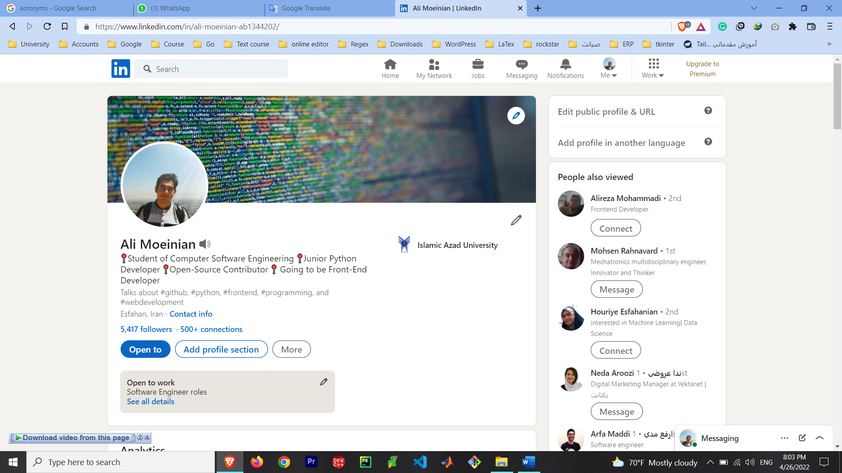

**I only use LinkedIn, I don’t have any Instagram or twitter account**

Previous tutorial files

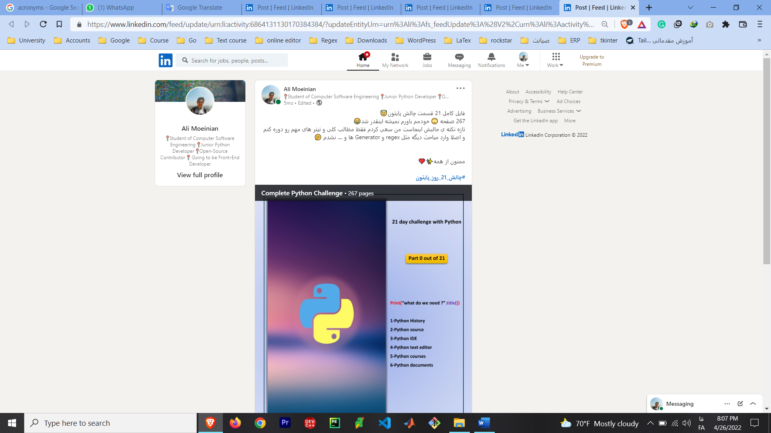

**Git and GitHub Summary**

**Python for beginners**

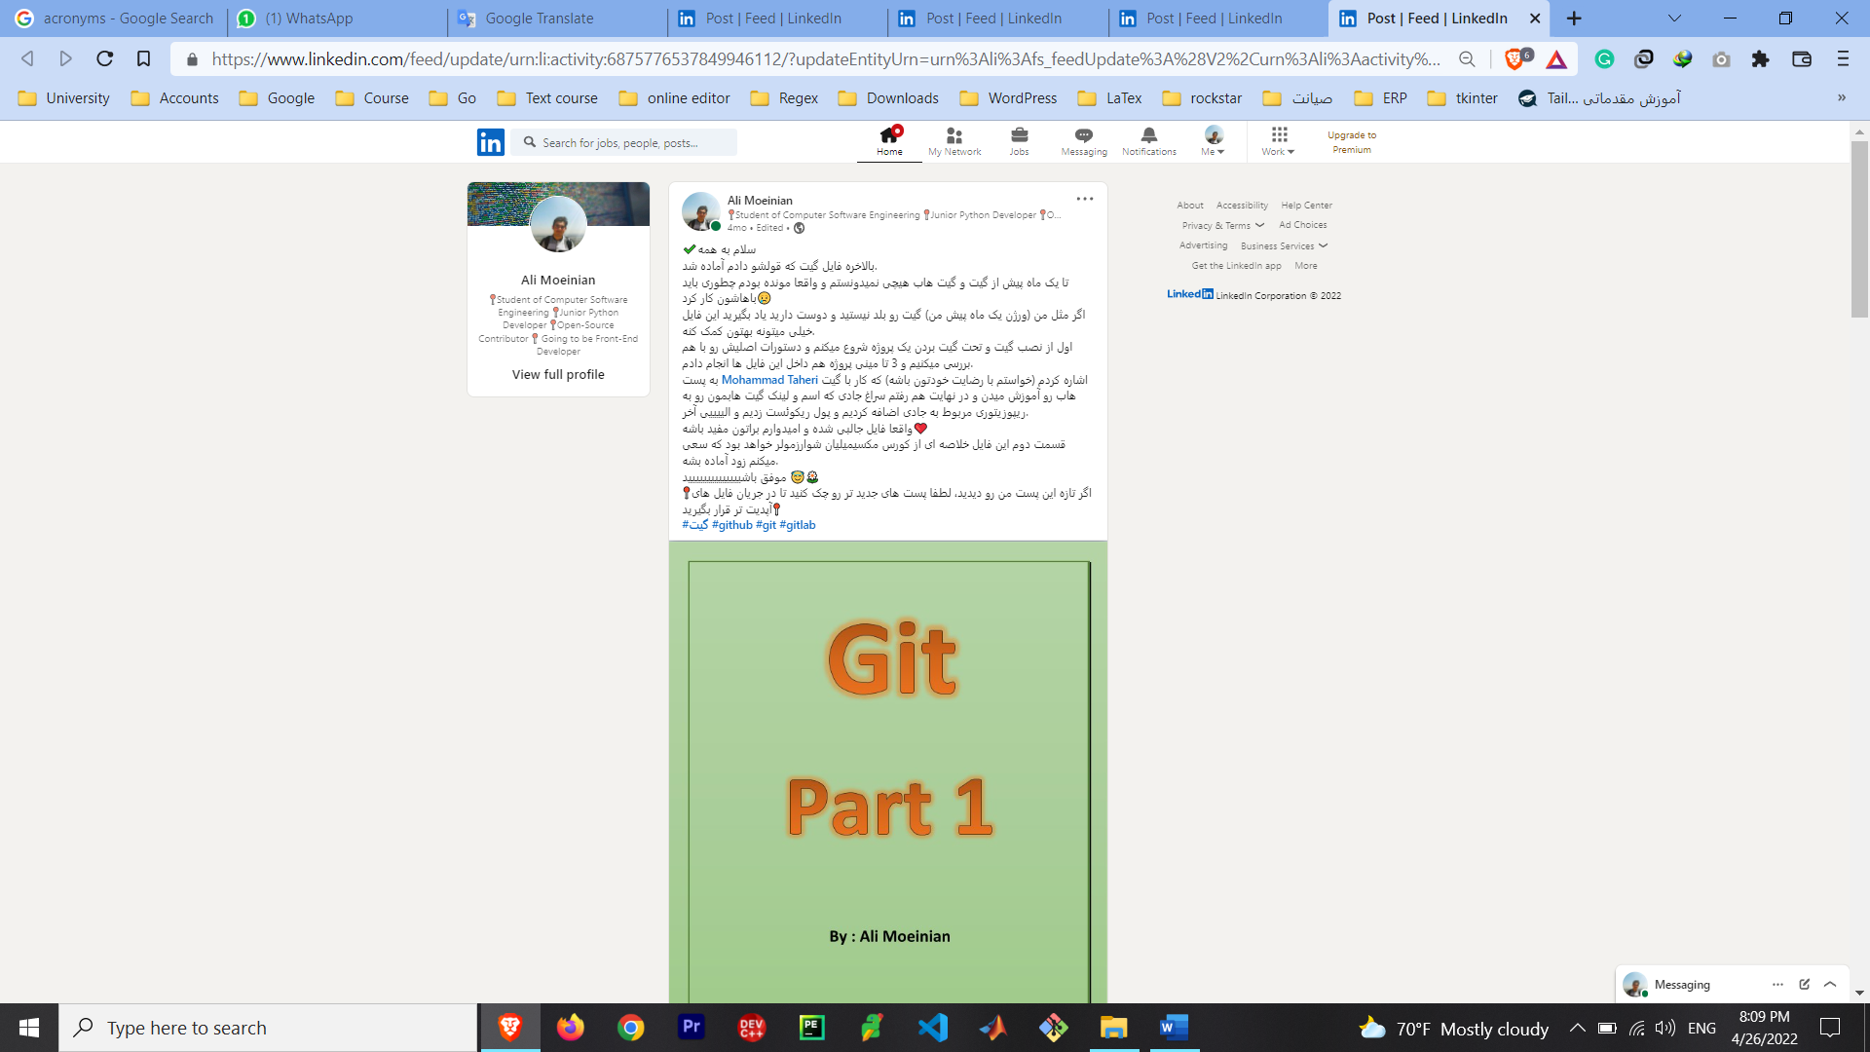

Previous tutorial files

**GitHub Licenses**

**EMMET Plugin**

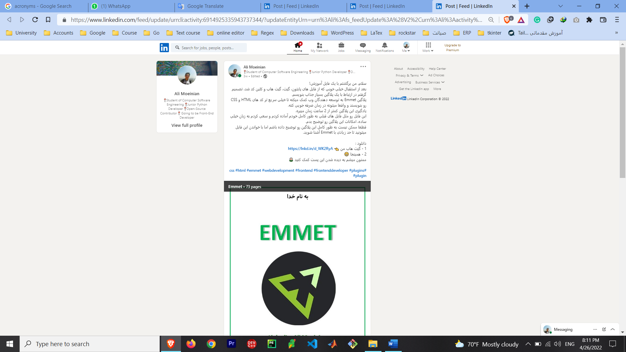

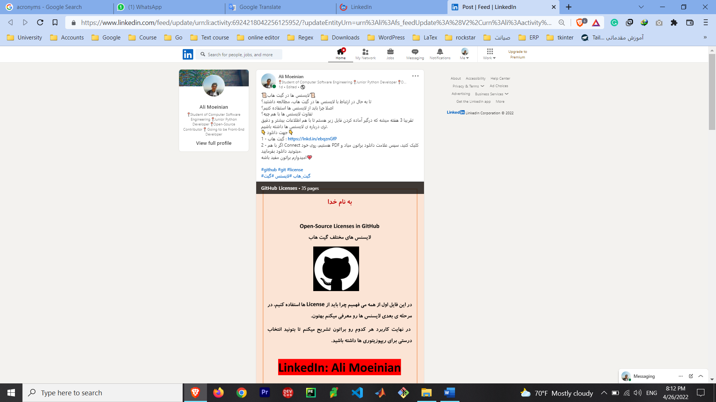

**N7M: Numeronym**

**Example**

**Definition**

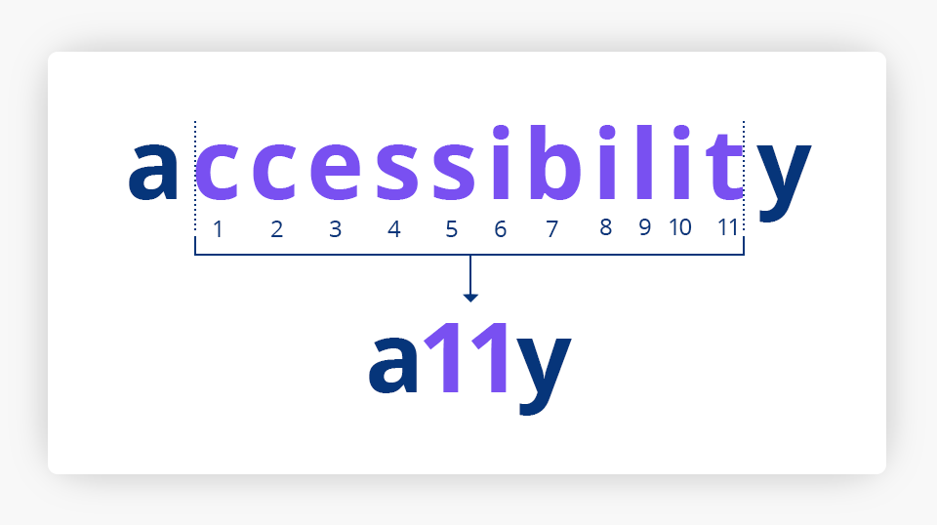

Number Based word.

A word where a number is used to form an abbreviation

👇 Examples 👇

**A11Y: Accessibility**

Accessibility is the practice of making your websites usable by as many people as possible.

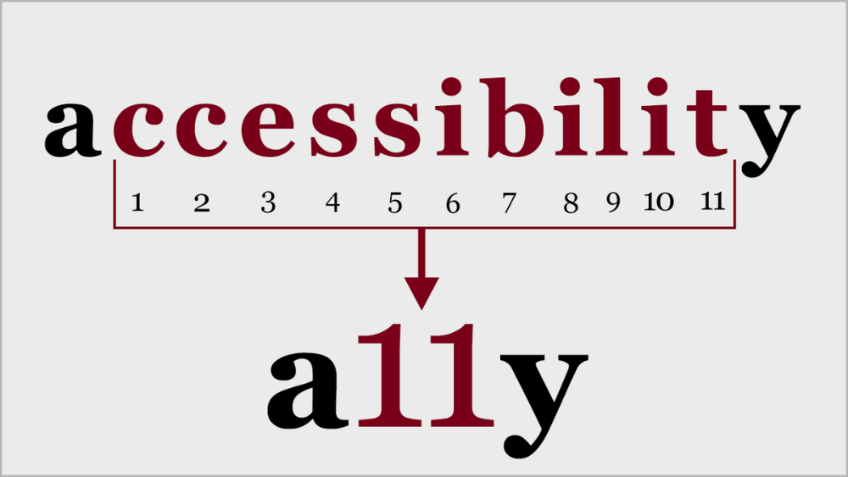معنای فارسی : دسترسی – آمادگی برای پذیرایی

**K8S: Kubernetes**

an open-source system for automating deployment, scaling, and management of containerized applications.

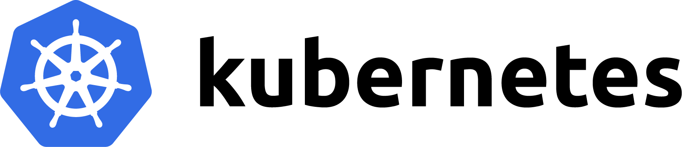

**I18N: Internationalization**

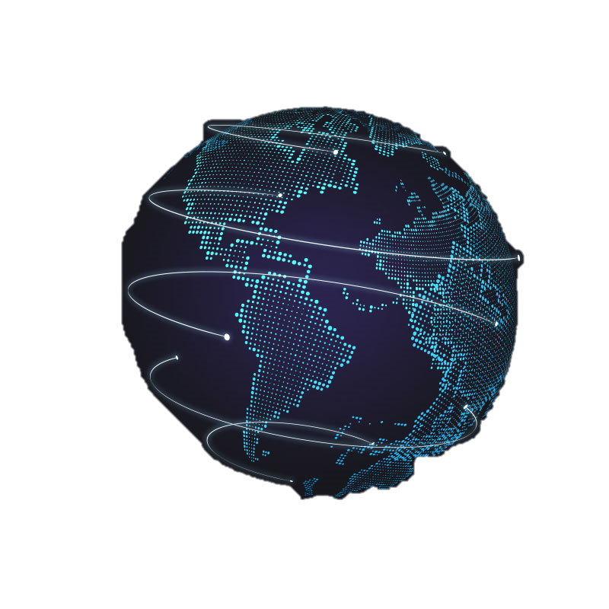

the process of designing a software application so that it can be adapted to various languages and regions without engineering changes.

معنای فارسی : بین المللی کردن

**L10N: Localization**

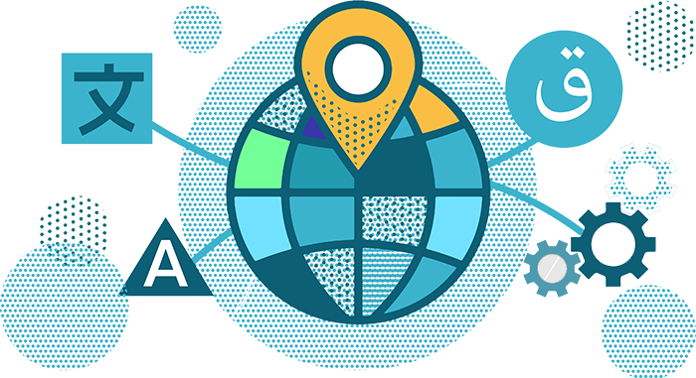The process of adapting software to both the culture and language of an end user, from standards of measurement to video and graphic design.

معنای فارسی: محلی سازی

L10N vs I18N

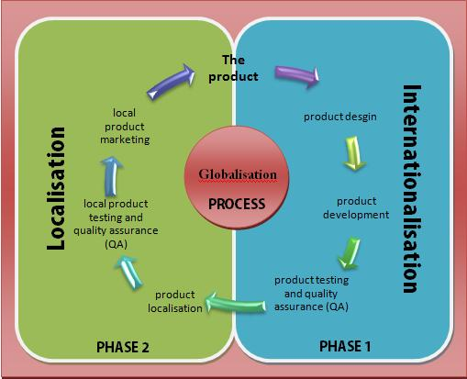

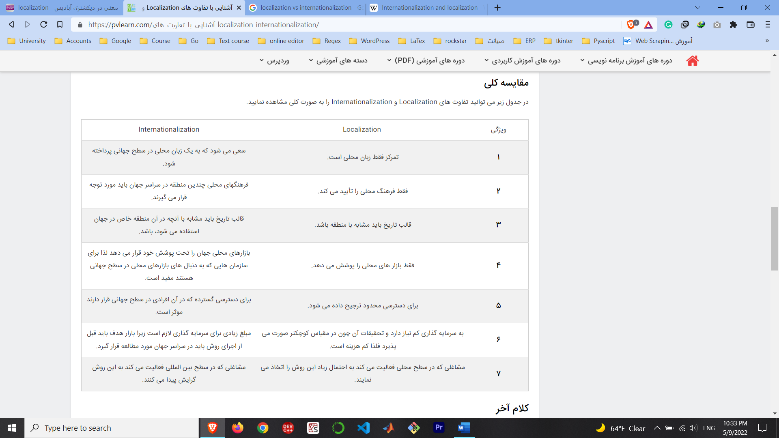L10N vs I18N

**V12N: Virtualization**

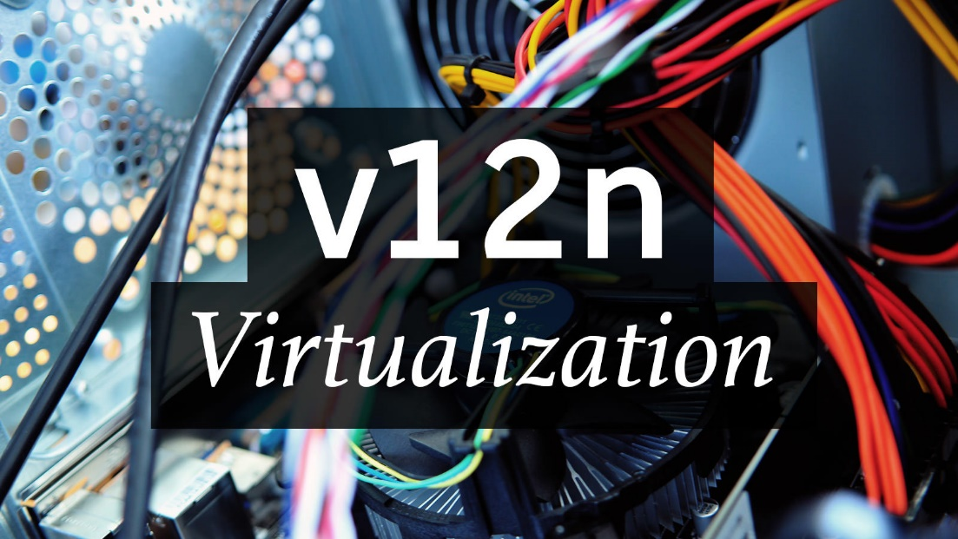

the act of creating a virtual version of something, including virtual computer hardware platforms, storage devices, and computer network resources.

معنای فارسی : مجازی سازی – ایجاد نمونه ی مجازی

**P13N: Personalization**



the action of designing or producing something to meet someone's individual requirements.

معنای فارسی : شخصی سازی

**C14N: Canonicalization**

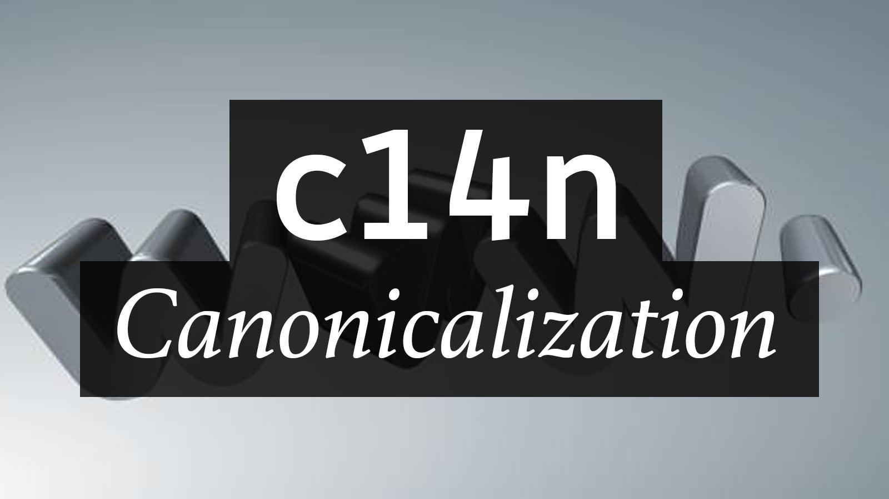

process for converting data that has more than one possible representation into a "standard", "normal", or canonical form.

معنای فارسی : متعارف سازی – استاندارد سازی

**M17n: Multilingualization**

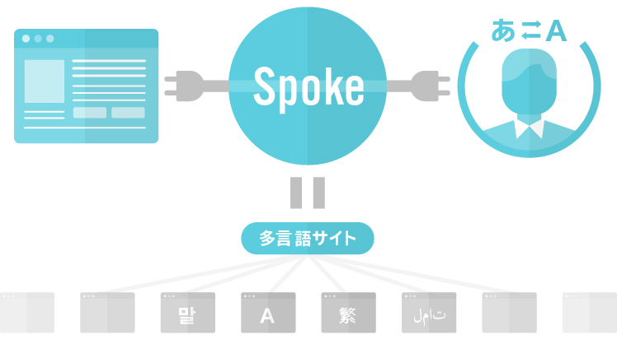

The act of adapting or localizing something to, into, or for multiple languages.

معنای فارسی : چند زبانه سازی

**G11N: Globalization**



a process of interaction and integration among the people, companies, and governments of different nations

معنای فارسی : جهانی سازی

**I14Y: Interoperability**



the basic ability of different computerized products or systems to readily connect and exchange information with one another, in either implementation or access, without restriction.

معنای فارسی : تعامل پذیری – قابلیت همکاری

**T9N: Translation**

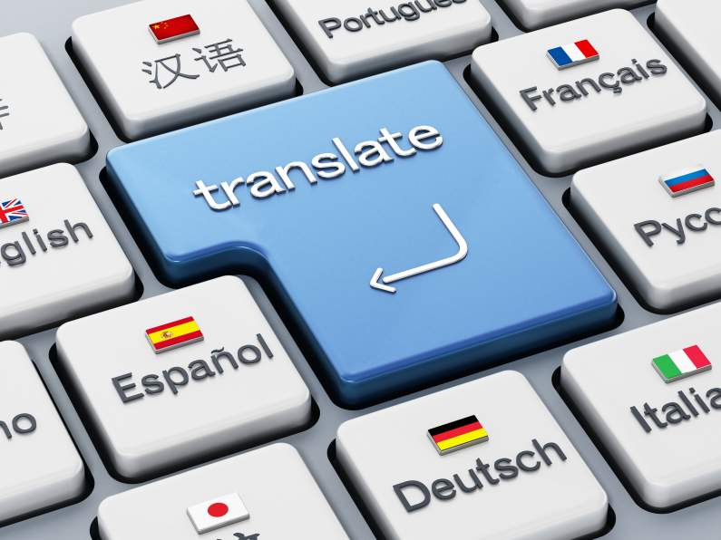the process of translating words or text from one language into another.

معنای فارسی : ترجمه

**H7K: Hyperlink**



a link from a hypertext document to another location, activated by clicking on a highlighted word or image.

معنای فارسی : ابر پیوند

**D11N: Documentation**



the information that describes the product to the people who develop, deploy and use it.

معنای فارسی : مستند سازی

**W12T: Web Development**



the tasks associated with creating, building, and maintaining websites and web applications that run online on a browser.

معنای فارسی : توسعه ی وب

**W3: World Wide Web**

an interconnected system of public webpages accessible through the Internet.



**C11N: Communication**

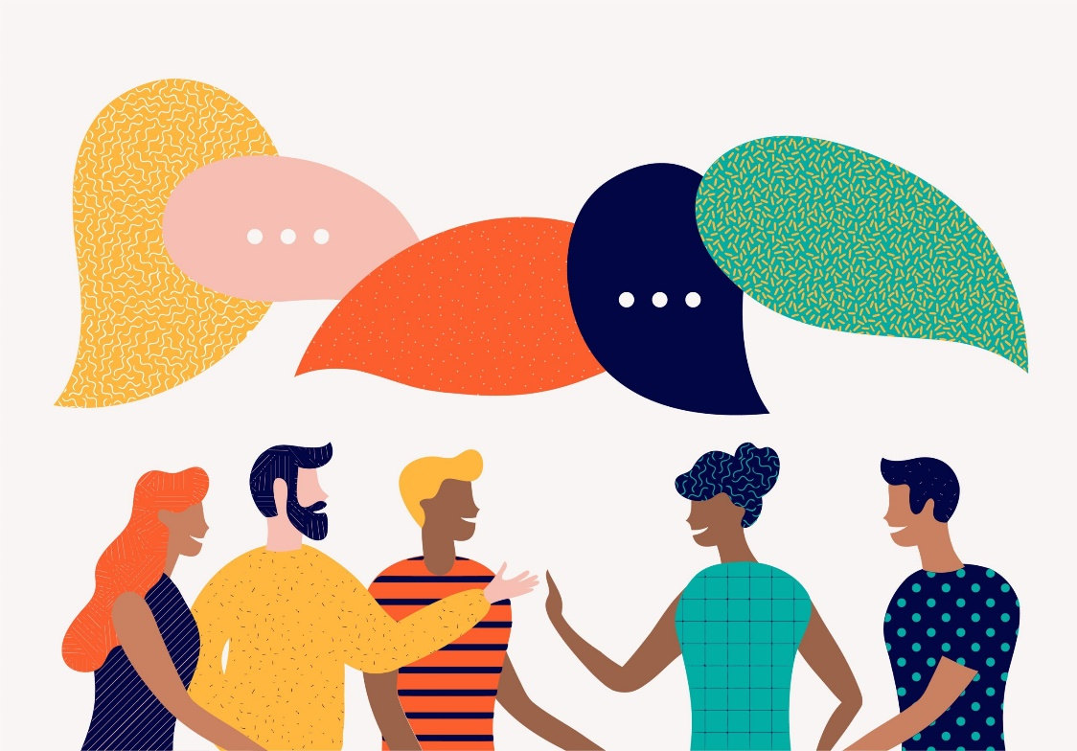

a process by which information is exchanged between individuals through a common system of symbols, signs, or behavior.

معنای فارسی : ارتباط

You can follow me on my LinkedIn Account





**Hope You enjoy 💗**

**By: Ali Moeinian**